Walk Walk Walk
Freestate Happy Wanderers
New Year’s Eve and New Year’s Day
Historic Savage, Maryland
Two 10-Km trails with 5-Km options
Two Events December 31, 2024 AT126869 AT126870
Two Events January 1, 2025 AT126871 AT126892

SPONSORED BY: Freestate Happy Wanderers Volksmarch Club, Inc. AVA-190

AVA: America’s Walking Club
Start/Finish area will be set-up to conform to the State of Maryland, Howard County and the United Methodist Church of Savage Rules and Restrictions that are in place at the time of the walk events. Correct change or checks appreciated.
START/FINISH: Savage United Methodist Church, 9050 Baltimore St. Savage, MD 20763. Located on the corner of Baltimore and Foundry Streets. See drive directions on back. Restrooms are available at the Start/Finish.
TIMES: Start both days anytime between 9 AM and 12 Noon, finish by 3:00 PM.
TRAILS: Trails are rated either 1A or 2B. Four 5-km trail options are available. Trails are on sidewalks, paved paths and natural wooded areas in and near the Savage Mill Historic District. Many options are possible, including a trail suitable for strollers. In addition, the walk box for the Savage YRE is available in the Savage Mill, Postmasters Office near the Start-Finish.
ELIGIBILITY: These walks are open to the public. Everyone is welcome to participate.
REGISTRATION: The fee for IVV Credit or Non-IVV Credit is $4.00. Children 12 and under (IVV-Credit included) walk for free courtesy of Freestate Happy Wanderers. The same trail may be walked for distance credit twice on the same start card on the same day with no extra charge.!
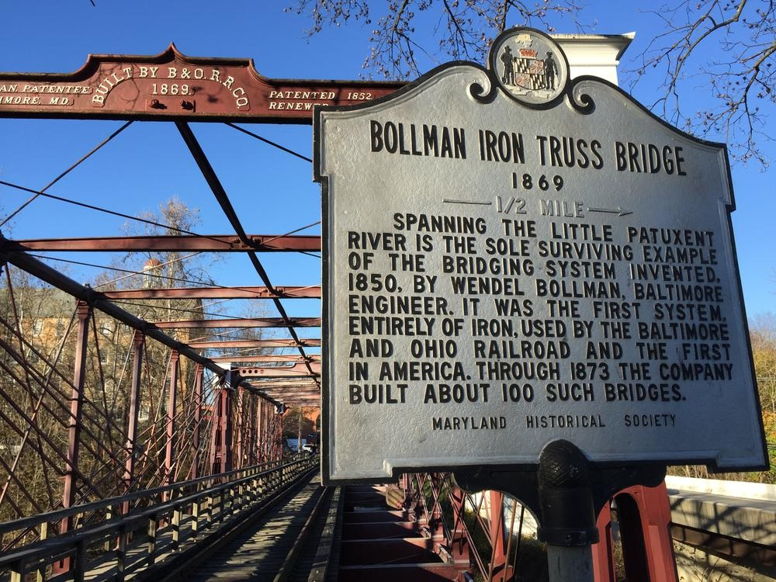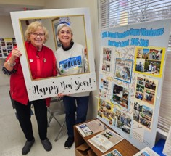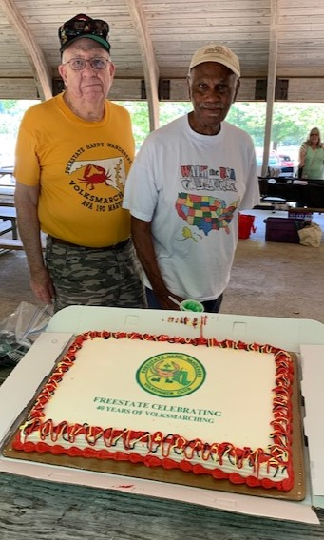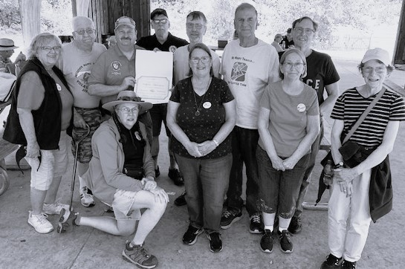
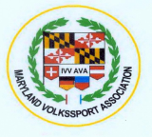

Fun, Fitness, Friendship
PROCEDURE: Each participant must register at the start and completely fill out a start card and including signing waiver. The start card is to be carried on the walk and presented at each checkpoint. Participants must turn in start cards at the Finish Table after completing the event. The AVA New Walker packet, which includes both IVV Books and 3 walk credit coupons, for sale at New Walker Table cost $10.
AVA SPECIAL PROGRAMS: A list of all qualifying AVA Special Programs will be available to participants at the Start/Finish table.
Walkers may earn six IVV Credit stamps at our two day event. Two traditional events both days (5-km/10-km trails) and the Savage YRE stamps for 2024 & 2025.
CONDITIONS: Littering along the trails is prohibited. Howard County law requires that all pets be leashed and that owners clean up after their pets. The event will be held in all reasonable weather. Pets NOT permitted in the Church Start/Finish Room. If weather conditions are uncertain, and traveler advisories are in effect on the days of the events, please call the contact person listed below to obtain up-to-date information on walk event status.
REFRESHMENTS: We are planning to serve food and drink in the Freestate tradition. Water and hard candy will be available both days.
DISCLAIMER: Every reasonable effort will be made to conduct a safe, enjoyable, and memorable event. The Freestate Happy Wanderers and the United Methodist Church of Savage shall not be liable for any accidents, theft, or material damage.
SANCTION: The Maryland Volkssport Association (MVA) and the American Volkssport Association (AVA), a member of the International Federation of Popular Sports (IVV), sanctioned these events, AT126869, AT1126870, AT126871 and AT126892
INFORMATION: Call 410-437-2164 (H), 410-533-5805 (C) before 9:00 PM or via email at wahasse1798@verizon.net.
DRIVE DIRECTIONS: FROM RT. I-95 NORTH OR SOUTH -TAKE EXIT FOR Rt. 32 EAST approx 1 mile to exit at US Rt.1 South toward Laurel for one block. *Turn Right at light on Howard St. which will become Baltimore St. Church is on the corners of Baltimore & Foundry Streets. FROM RT. 295 NORTH OR SOUTH BALTO/WASH PKWY, TAKE EXIT FOR RT. 32 WEST toward Columbia., TAKE EXIT RT 1 South for Historic Savage. ,*FOLLOW DIRECTIONS ABOVE: Parking is allowed in the Church parking lot & on streets OBEY ALL SIGNS & RESTRICTIONS:

Enjoy our YRE’s and earn “I Walked ‘Em All” Patch
Bowie -Y0390, Cambridge Y1046, Chesapeake Beach Y1087
Colesville Y3417 (OSB)
Glen Burnie Airport Observation Trail Y1360
Kinder Farm Park Y1896
Indian Head Y0129, Laurel Y2019, Mount Airy Y1359 (OSB)
Ocean City Walk Y1572 (PSB & OSB)
Ocean City Bike YRE 3185 (OSB)
Savage Mill Y0575, St. Mary’s City Y1620 (OSB)
Ft. Smallwood Park Y2767 (OSB)
Wheaton Y1619 (PSB & OSB) Y0144 (PSB)

